Language Web App Documentation

By Simon Chen

Contents

Introduction 2

The brief 2

Expectation vs Reality 3

The language application 4

CI (Continuous Integration) Pipeline 4

Risk assessment 4

Testing and Coverage 5

Future Development 6

# Introduction

## The brief

The scope of the project was as following:

* The use of any form of Kanban board- for this project Trello was selected
* The creation of at least two tables within a relational database that is used to store persistent data- this was done through the GCP (Google Cloud Platform) MySQL server
* The creation of documentation that contains risk assessment and architecture design
* The use of Flask, together with Python, to create a functional web application
* The demonstration of testing and coverage of the application
* The integration of VCS (Version Control System) with the source code, build through a CI server- Jenkins and deployed using a cloud-based virtual machine- GCP

## Expectation vs Reality

The initial idea was to make five tables: Users, Vocabulary, Difficulty, Language, and Learner.

However due to time constraint, this was reduced to two simple tables: Users and Vocabulary.

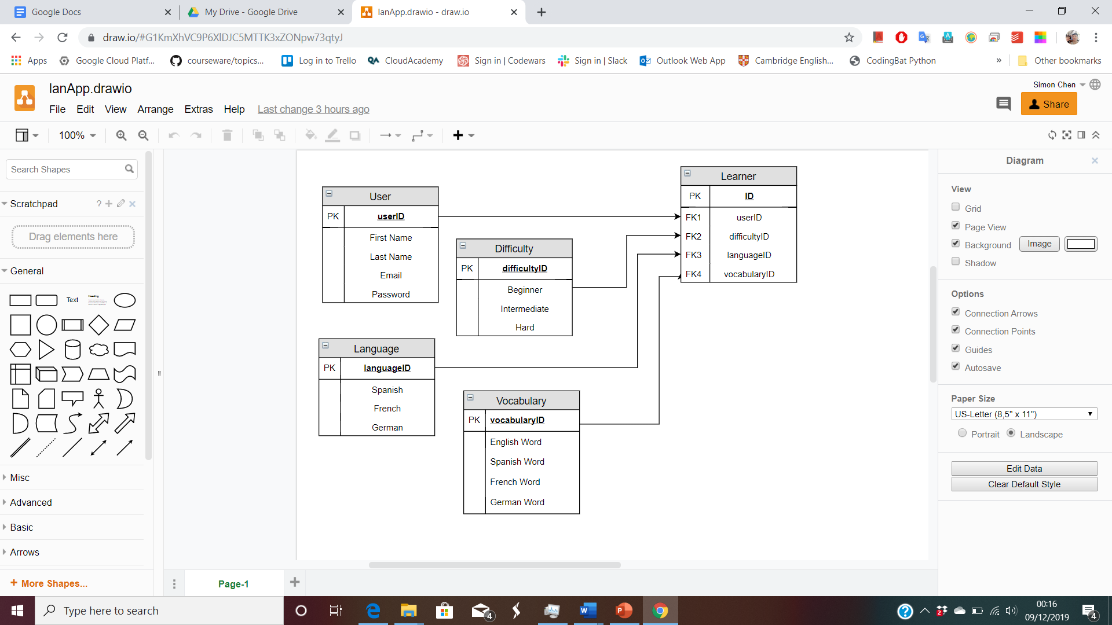

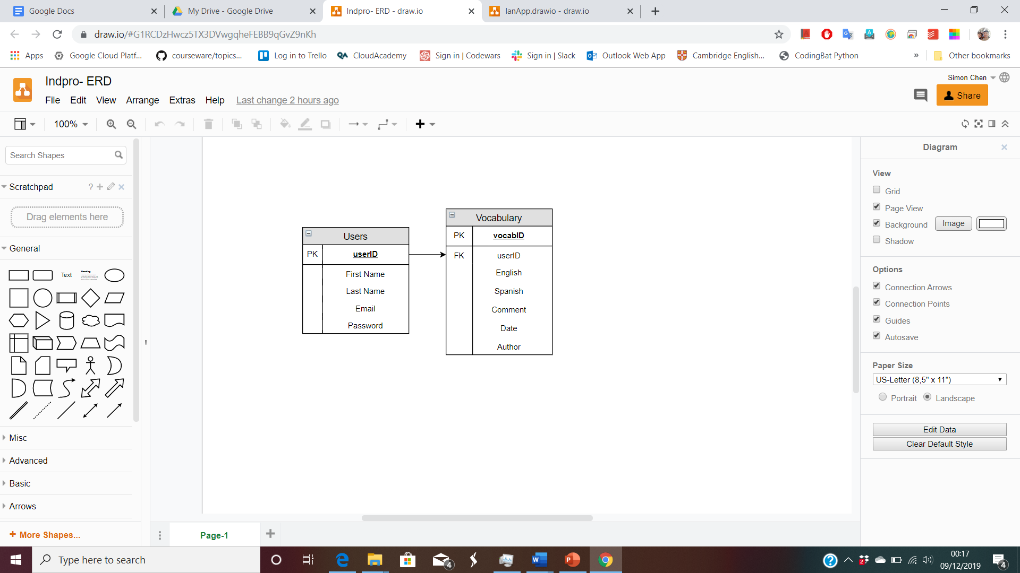

## The language application

The purpose of the language app is to help English speakers to learn Spanish through collective input of Spanish vocabularies from the community.

The app has the following features:

* A Register Page to sign up in order to add their translation to the table
* A Login Page once registered
* An Add Page to insert entries into the table
* A Delete Page to delete the account and its entries
* An Account Page to update account information
* A Logout feature if logged in

# 

# CI (Continuous Integration) Pipeline

The CI pipeline is the relationship between different software that helps to automate the development process of early build stage of an application.

For this project the following software and methods are used to create this pipeline:

Project management style- agile

Software used in this project

* Jenkins- CI server
* Google Cloud Platform (GCP)- Cloud server
* Trello- Project Management tool/Kanban board
* Github- git repository
* Flask- micro-framework
* Git- VCS
* GCP MySQL server- database

Programming languages used

* Python

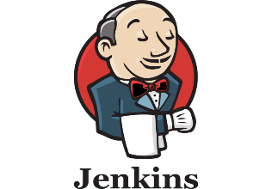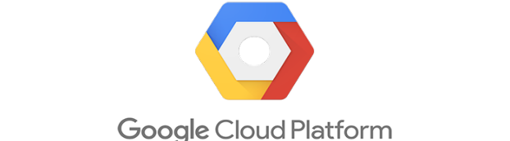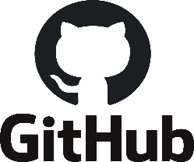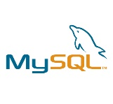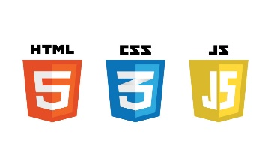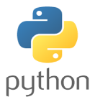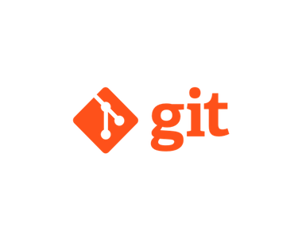

* HTML
* Linux

# Risk assessment

Risk is measured by the severity of the impact multiply by the likelihood of occurrence of the risk itself.

The risks are listed below upon consideration

* Failure to satisfy the project brief
* Failure to understand the concept of the pipeline
* Unable to solve bug- low impact/high likelihood
* Lost work due to lack of understanding on certain software such as Github

# Testing and Coverage

Six tests were carried out, which covered the testing of viewing the home page, login page, update page; and the testing of adding to the table; and updating and deleting the account. All tests have passed with 59% coverage.

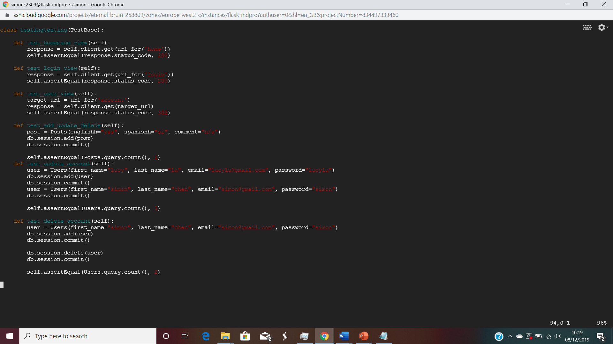

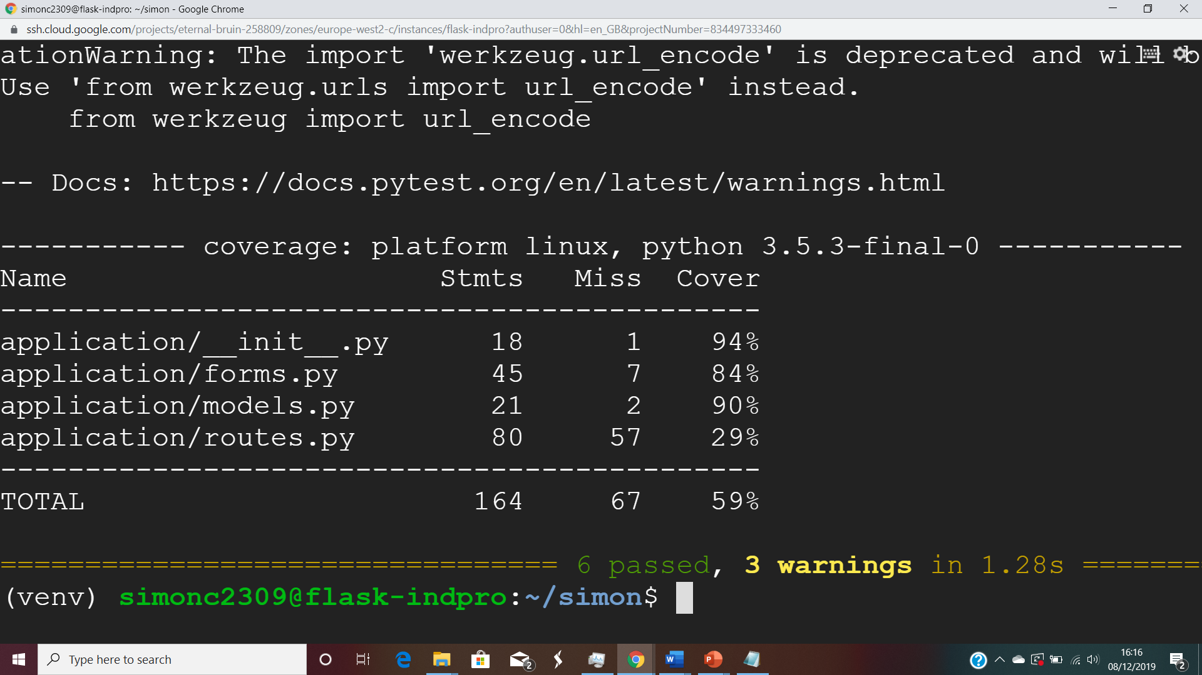

# Future Development

Additional of features to further increase the convenience of the user include:

* Import English and Spanish dictionary/library
* Update and delete table entry feature
* More language options
* Offer to other than English speakers
* Add difficulty levels
* Ranking of users
* Improvement of front-end design using CSS and JS